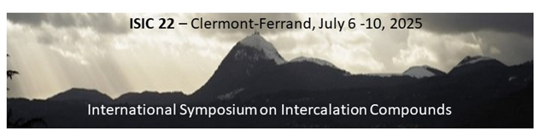

**Submission of contribution to ISIC 22**

|  |  |
| --- | --- |
| Author name |  |
| Affiliation |  |
| E-mail: |  |

Please indicate the preferred mode of presentation:

**[ ] *Oral Presentation***

**[ ] *Poster Presentation***

**[ ] *Either***

Please fill this form, prepare your abstract following the template below and then submit your contribution by e-mail to:

[isic22-sci@sciencesconf.org](mailto:isic22-sci@sciencesconf.org)

before March 10, 2025 Title

First Author1, Second Author2, Corresponding Author1* (underline the presenting author, put an asterisk (*) after the name of the corresponding author; use initials for first and middle names)

1 Institution. Department. Address. Country; 2 Institution. Department. Address. Country…

(*) corresponding.author@email.com

This is a set of instructions for preparing your paper. These instructions have been formatted to look like your paper. In case of question, please contact us.

Absolutely limit your abstract to **1 A4 page** (210 x 297 mm), including Tables, Figures and References.

The paper in electronic format should be sent before **March 10,** **2025** as an e-mail attachment in WORD format to [isic22-sci@sciencesconf.org](mailto:isic22-sci@sciencesconf.org)

The one-page abstract must be in English (11-point, Arial font, single line spacing) and left and right, top and bottom margins of 2 cm.

All pages must be in portrait orientation. Use only single column format as shown here. Full justification should be used.

On the top of the page, place the title of the paper (*bold, 12-point, Arial font, aligned centre*). Leave one blank lines of 11-point font, and then list authors (*11-point Arial font, aligned centre*).

Each author’s current affiliation should include full address and email if applicable, (*11-point Arial font, justified*).

References

[1] F.M. Last name, Abbreviated-journal-name **volume** (year) page-numbers *(11-point Arial font)*